**Section B**

**F17-8161**

**CN lab 9**

**Q 1**:

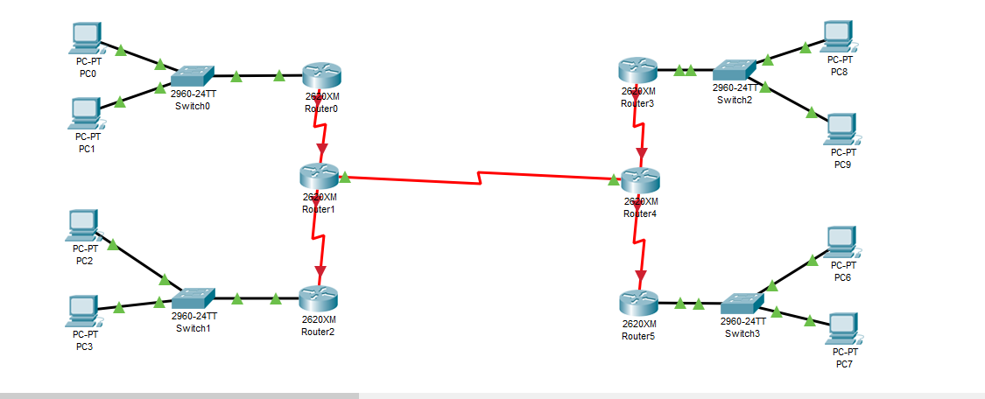

Net A: 204.15.5.0/27

host address range 1 to 30

Net B: 204.15.5.32/27

host address range 33 to 62

Net C: 204.15.5.64/27

host address range 65 to 94

Net D: 204.15.5.96/27

host address range 97 to 126

Net E: 204.15.5.128/27

host address range 129 to 158

router 0 ip

Pc 0 host A ip

And so on

Pc1 host A IP: 204.15.3

Pc1 host A subnet mask: 255.255.255.224

Pc2 host B IP: 204.15.34

Pc2 host B subnet mask: 255.255.255.224

Pc3 host B IP: 204.15.35

Pc3 host B subnet mask: 255.255.255.224

Host C1 IP: 204.15.66

Subnet Mask: 255.255.255.224

Host C2 IP: 204.15.67

Subnet Mask: 255.255.255.224

Pc8 host D IP: 204.15.98

Pc8 host D subnet mask: 255.255.255.224

Pc9 host D IP: 204.15.99

Pc9 host D subnet mask: 255.255.255.224

Pc6 host E IP: 204.15.130

Pc6 host E subnet mask: 255.255.255.224

Pc7 host E IP: 204.15.131

Pc7 host E subnet mask: 255.255.255.224

We represented 2 host as drawing 14,28 host will be difficult

**Q 2:**

|  |  |  |  |  |  |  |  |
| --- | --- | --- | --- | --- | --- | --- | --- |
| **Subnet Name** | **Size** | **Allocated Size** | **Address** | **Mask** | **Dec Mask** | **Range** | **Broadcast** |
| A | 120 | 126 | 192.168.1.0 | /25 | 255.255.255.128 | 192.168.1.1 to 192.168.1.126 | 192.168.1.127 |
| B | 55 | 62 | 192.168.1.128 | /26 | 255.255.255.192 | 192.168.1.129 to 192.168.1.190 | 192.168.1.191 |
| C | 20 | 30 | 192.168.1.192 | /27 | 255.255.255.224 | 192.168.1.193 to 192.168.1.222 | 192.168.1.223 |
| D | 11 | 14 | 192.168.1.224 | /28 | 255.255.255.240 | 192.168.1.225 to 192.168.1.238 | 192.168.1.239 |
| E | 2 | 2 | 192.168.1.240 | /30 | 255.255.255.252 | 192.168.1.241 to 192.168.1.242 | 192.168.1.243 |
| F | 2 | 2 | 192.168.1.244 | /30 | 255.255.255.252 | 192.168.1.245 to 192.168.1.1246 | 192.168.1.247 |
| G | 2 | 2 | 192.168.1.248 | /30 | 255.255.255.152 | 192.168.1.249 to 192.168.1.250 | 192.168.1.251 |

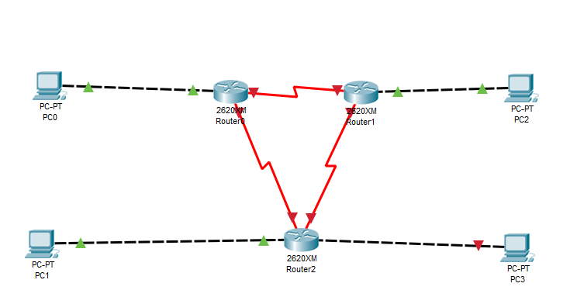

**NetA:**

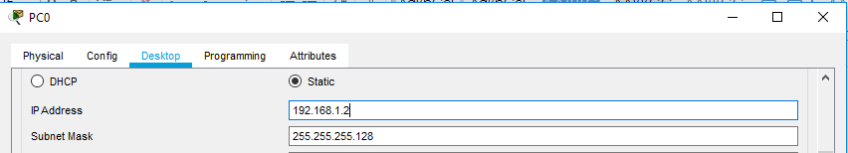

**NetB:**

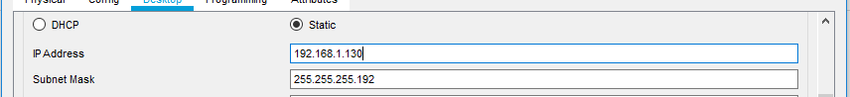

**NetC:**

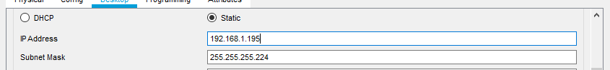

**NetD:**



**NetE:**



**NetF:**



**NetG:**

